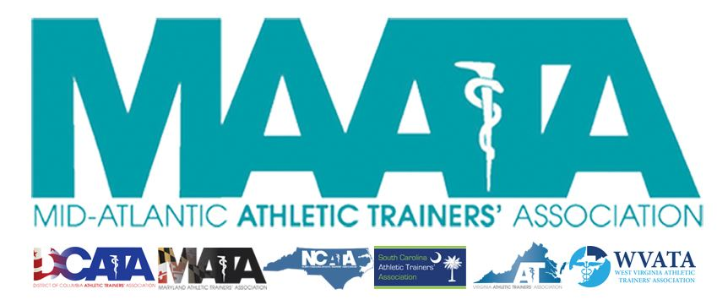

**District Council Conference Call Minutes**

**October 19, 2022**

**8:30am**

1. **Call to Order** 
   * President Cole called the meeting to order at approximately 8:30am.
2. **Roll Call:**
   * **Members Present:**
     + Steve Cole – District President
     + Ray Davis – District Director
     + Donita Valentine – District Vice-President
     + Jason Mitchell – District Secretary
     + Jay Sedory – District Treasurer
     + Katie Walsh Flanagan – Past District Director
     + Christina Carrillo – President, DCATA
     + Jean Perez – President, MATA
     + Nina Walker – President, NCATA
     + Amy Hand – President, SCATA
     + Danny Carroll – President, VATA
     + Tom Belmaggio – President, WVATA
   * **Guests Present:**
     + Marty Sataloff – District Parliamentarian
     + Jenni Johnson – D3 Rep to NATA Connection & Engagement Committee
     + Marty Baker – D3 Rep to NATA Foundation
     + Emily Hildebrand – Student Senate Faculty Advisor
     + Scott Cook – District Vice-President Elect
     + Erin Cash – District Secretary Elect

* **Past-District Director – Katie Walsh Flanagan**
  + Election Updates
    - Welcome Scott Cook as the newly announced District Vice-President Elect
    - Welcome Erin Cash as the newly announced District Secretary Elect
    - Reviewed voting data with state breakdowns
      * District Secretary Election
        + 233 total votes

Breakdown by state

DC – 6

MD – 23

NC – 57

SC – 68

VA – 70

WV – 9

1. **NATA Connection & Engagement Committee – Jenni Johnson**
   1. NATA recognizing District 3 on 12/3/2022 on D3 day!
      1. Encouraging members to push the word on our membership renewals
   2. Committee discussing promoting new members
      1. New members who post on social media will enter contest to win prizes!
      2. Will send out into to State Presidents to help push this out to members
2. **NATA Foundation – Marty Baker**
   1. Discussed the re-implementation of Foundation Ambassador program
      1. Foundation’s version of state leadership in helping it fulfill its mission
         1. Looking for state representation to help volunteer with Marty Baker to assist in Foundational activities
      2. Circle of Champions
         1. Encourage everyone to consider joining a member of Circle of Champions
            1. Monthly recurring gift to the Foundation
3. **State Presidents Reports:**
   1. *District of Columbia* – Christina Carrillo
      1. TUFFS meeting w/ KSI
         1. Targeted DC Fire & EMS departments
      2. Starting a safety in football campaign with Secondary Schools starting Nov 1-15
         1. There are several charter schools who do not employ an AT and hire EMT for emergency services
      3. Continuing to work with members to fill vacant state rep positions in District committees
   2. *Maryland* – Jean Perez
      1. Lobby day – January 12
         1. Reintroducing dry needling
      2. DEI committee
         1. Co-sponsored event with Dr. Holmes on Sept 25 regarding Diversity in Dermatology
   3. *North Carolina* – Nina Walker
      1. DEI “Can We Talk” sessions
      2. Updating Policies & Procedures
         1. Looking at processes with the District level
      3. BEATS – Boosting up Excellence in Athletic Training Students
         1. Engaging students & helping them gain mentorship
         2. Baltimore is doing a great job in marrying HCBUs & Athletic Training programs
            1. Goals is creating a pipeline between HCBUs & Athletic Training programs to raise awareness of AT & increase diversity of AT students
      4. State Advisory Committee update -
         1. November – State Leader Month
         2. Diversity survey has been sent out to the District
            1. Please encourage members to complete
   4. *South Carolina* – Amy Hand
      1. Finalizing details with new lobbyist
         1. Hoping & pushing for a bill to be ready in January
   5. *Virginia* – Danny Carroll
      1. Finalizing details of annual meeting
         1. January 13-15, 2023, in Harrisonburg, VA
      2. Continuing to work with State High School associating with the purchasing & distribution of kestrel units
         1. Happy to report that Secondary Schools committee was able to use money earned at their annual symposium to purchase 11 kestrel units that will be distributed to private schools that were not included in the original grant
      3. Researchs & Grants Committee
         1. All submissions have been received, and committee will be scheduling soon to review them
      4. VA Governor have released a model policy for public schools
         1. Some of the language could be potentially divisive, especially regarding trans-gender students
         2. Currently drafting language to provide a HCP stance, and to also provide secondary school ATs guidance
      5. Lobbyist is meeting this week with representative of Board of Medicine to try to determine how to navigate moving forward with emerging competencies (e.g. dry needling, wound closures, etc.)
   6. *West Virginia* – Tom Belmaggio
      1. Refreshed website, moved to a platform to ease the editing process
      2. Introduce 2 bills
         1. Drafting up a Safe Sport bill, which includes that EAPs, heat-illness plans, tackling education (for football), concussion education, CPR/AED certification need to be implemented with all youth sports participation
         2. Pushing forward with bill for AT coverage in every Secondary Schools
         3. Brainstorming with lobbyist on different fundraising ideas
      3. Secondary School AT Committee
         1. Looking at creating a educational program sometime this upcoming Spring/Summer for Secondary Schools ATs within the District.
4. **District Director – Ray Davis**
   1. NATA Updates
      1. Finalizing some volunteer position openings, in hopes of completion by the end of this month
      2. Reminder that gATher is the platform for applying for volunteer positions to the NATA
      3. Membership benefits
         1. Access to NATAPAC, which is our primary advocacy at the Federal level
5. **District Treasurer – Jay Sedory**
   1. Discussed current financial report
      1. Financial Advisory Committee
         1. Still waiting of 3rd/4th quarter dues
         2. This will give us more information on how the finances look for this year
         3. Primary concern is future budgeting for Annual Meeting
            1. Committee needs further discussion
6. **District Vice-President – Donita Valentine**
   1. Annual Meeting update
      1. May 19-21, 2022 @ Founder’s Inn in Virginia Beach, VA
      2. Call for Proposals is out and live
      3. Meeting registration – opening January 9
   2. BOC Standards
      1. Implemented the IDEAS committee and working with Standards to come up with language that is conducive & reflective on how ATs practice.
7. **District Secretary – Jason Mitchell**
   1. Approval of minutes of previous District Council Meeting – (09/21/2022)
      1. Motion to approve – WV President Belmaggio
         1. 2nd – VA President Carroll
         2. No discussion
      2. Passed – 11-0-0
   2. Presented current District Member & National member data at a glance
8. **Student Senate Updates – Emily Hildebrand**
   1. Still waiting on some votes to complete the student committee positions
9. **District President – Steve Cole**
   1. MAATA Updates
      1. NATA will be releasing additional information from the NATA Strategic Plan presentation that State Presidents can review to help drive messaging for membership renewals
      2. Governance Task Force update
         1. First call last month
            1. Next meeting, October 26
            2. Continuing to look at pending revisions in District Constitution & By-Laws
            3. Looking at language with elected officers on duties within the signed Letter of Obligations and updating mechanisms for how officers can be removed from office, if needed.
10. **Adjournment of meeting**
    1. Motion to adjourn meeting – VA President Carroll
       1. 2nd – WV President Belmaggio
       2. Approved 11-0-0
       3. Meeting was adjourned 9:55am.